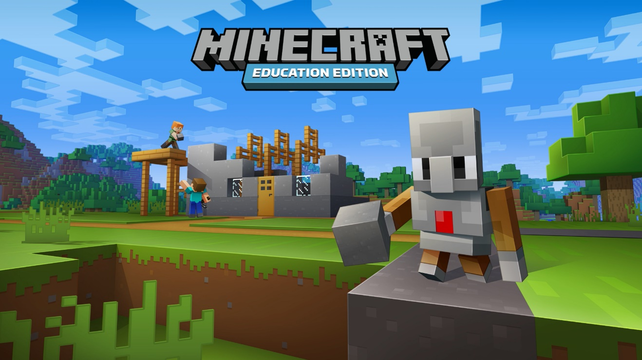

|  |  |  |
| --- | --- | --- |
| When planning a lesson, it is of high importance that you first determine what you want students to learn and do inside the lesson. Keep in mind, Minecraft is a great visual tool that can assist with visual representation of understanding of abstract concepts. | | |
|  | | |
| Topic | Class | Time |
|  |  |  |
| Student Learning Outcomes: What subject matter objectives will be met with the lesson? Think about what cross-curricular objectives will also be met? | | |
|  | | |
| Prior Knowledge/Learning: What have students already done to prepare them for this lesson? | | |
|  | | |
| Teacher Learning: What do you need to learn as you develop the lesson and your Minecraft Education Edition skills? | | |
|  | | |
| Resources: What out of game/in game (worlds) resources will students need for this lesson? | | |
|  | | |
| Content Based Standards: Listing or linking to standards is important when building a lesson plan that fits into larger units of study. | | |
|  | | |

|  |
| --- |
| Lesson Plan: What will be happening in the classroom during the lesson. |
| |  |  |  |  |  | | --- | --- | --- | --- | --- | | Time | Student/Teacher Activity | Differentiation Opportunities | Formative Assessment Opportunities and how will you adjust lesson based on feedback? | Anticipated In-Game Challenges | |  |  |  |  |  | |  |  |  |  |  | |  |  |  |  |  | |  |  |  |  |  | |  |  |  |  |  | |

|  |
| --- |
| Assessment: What evidence will you collect to determine whether learning objectives were achieved? |
|  |
| Pre-Lesson Learning Plan Reflection: Reflect on these questions and adjust lesson based on your answers. |
| * Does the learning plan reflect principles of learning and best practices? * Have you considered how to fully engage everyone and hold their interest throughout? * Is there tight alignment between objectives, standards and student activities? |
| Post Learning Plan Reflection: Reflect on these questions after you have taught this lesson. |
| * Does your assessment data reflect the learning outcomes you had hoped for with this lesson? * Do you feel that students were fully engage throughout this lesson? If they weren’t, what did you do to re-engage them in the lesson and why do you think they were disconnected from the content? * What would you change when doing this lesson again? |